Homework Assignment 5

Tyler Paulley

11/6/2016

**The sorting method that I added was merge sort as can be seen as the 5th selection when the program runs.**

**Proving that the sorting method works:**

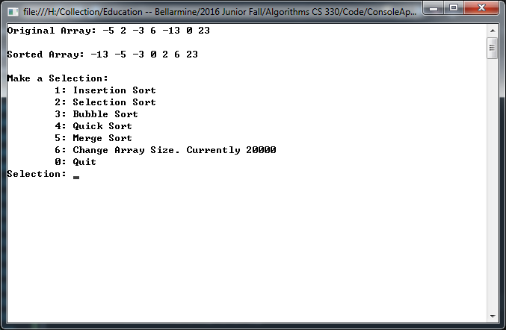

**Example of the sorting code: 200,000 items**

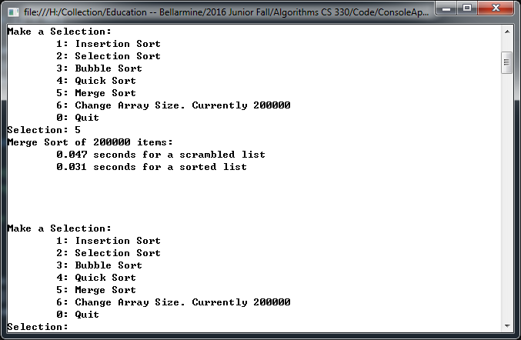

**Example of the sorting code: 2,000,000 items**

